**EXPERIMENT:3b**

**DATE:7.8.24**

**CRIMPING OF CABLE WITH RJ45 CONNNECTOR**

**AIM:** Study of RJ45 and CAT cabling and connection using crimping tool.

**RESOURCES REQUIRED:**H/W Requirements: RJ45, CAT cables, Crimping Tool, and Internet Connection.

**THEORY:  
RJ45:**RJ45 cable is used for connect the ALL HMI and engineer station through a switch to communicated each other. It is used to download the any modification and which is made in graphics in engineering station. RJ45 cable also used for communicate the printer with computer. There are four pairs of wires in an Ethernet cable, and an Ethernet connector (8P8C) has eight pin slots. Each pin is identified by a number, starting from left to right, with the clip facing away from you.

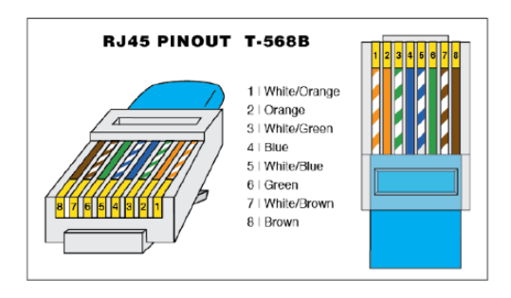

There are two kinds of Ethernet cables used for communication:

1. Straight Through
2. Cross over cable

**STRAIGHT THROUGH CABLE:**

STRAIGHT THROUGH Ethernet cables are the standard cables used for almost all purposes and are often called “patch cables.” It is highly recommended you duplicate the color order as shown on the left. Note how the green pair is not side-by-side as are all the other pairs. This configuration allows for longer wire runs.

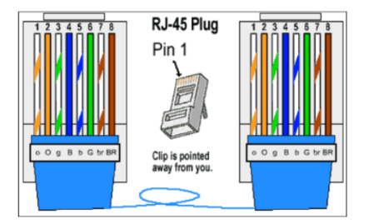

**CROSSOVER CABLES:**

The purpose of a Crossover Ethernet cable is to directly connect one computer to another computer (or device) without going through a router, switch, or hub.

A crossover RJ45 cable directly connects two similar devices (e.g., two computers or two switches) without needing a router or switch. The wiring involves swapping certain pairs of wires: one end follows the T568A standard and the other follows the T568B standard. This crossover allows the transmit (TX) and receive (RX) signals to cross, enabling proper communication between devices. Crossover cables are particularly useful for connecting older devices that lack auto-sensing capabilities.

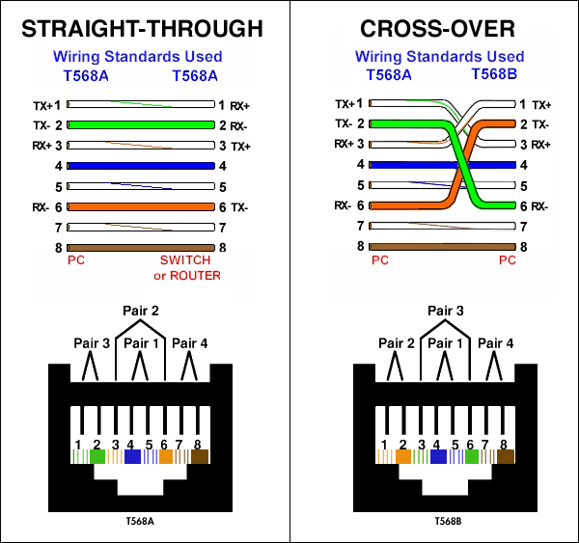

**CRIMPING TOOL:**

Crimpers are tools used to make cold weld joints between two wires or a wire and a connector, such as lugs. Ideally, the electrical and mechanical properties of the weld joint are as strong as the parent materials. Crimping tools are sized according to the wire gauges (using AWG - American Wire Gauge) they can accept. Some come with interchangeable die heads that allow for a wider range of wire sizes and connectors.

**How to use:**

First, you will need to strip the length of wire that you want to crimp. Then, attach the connector. For crimping tools with interchangeable dies, you will need to select the right die head for the connector by matching wire gauge ratings. For dieless crimpers, you will need to match to the proper groove. Finally, apply pressure, take out the newly crimped connector, and give a few tugs to make sure you have a solid and secure connection.

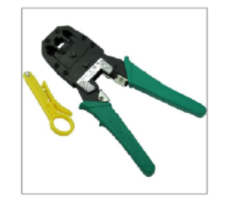

**CONCLUSION:** Hence, crimping of cable with rj45 connnector is studied.